Final Report
Home Security Threat Analysis
  - Luke Savage(C00248077) - 4th Year Cybercrime & IT Security

Contents
Introduction 2
Description of Submitted Project 2
Description of Conformance to Specification and Design 4
Description of Learning 5
Technical Learning 5
Personal Learning 5
Review of Project 6
Acknowledgements 6
Plagiarism Declaration 7

Introduction
In this document I will go over the description of my submitted project, what the final product of my project is, how it runs with screenshots of both the GUI (Graphical User Interface) side of the project, and the code involved in creating it. I will also be covering whether the project matches the specifications and designs from previous documentation, and reasons as to why changes were made to allow for the completion of the project. I will cover what I have learned throughout working on this project, both Technical and Personal learning and my achievements in both types. Technical learning is what I had to learn for this project, and Personal learning is what I learned about myself when working on the project. There will also be a Review of Project added, this will cover my reflection of the experience: whether I thought it went right or wrong; If there is anything missing or still left to do; If I was to start the whole project again, how would I go about it differently; If were to advise someone doing this project in the future, what advice would I give them, etc. Finally, I will add an acknowledgement to thank those who helped me throughout the project and its completion.

Description of Submitted Project
My finished product is a simple to use network scanner. The GUI used for the project was completely made using Java code for each page. The scanner was created with a few java commands that takes the devices IP address and replaces the digits after the last “.” Into “.0/24” (for example 192.168.1.1 becomes 192.168.1.0/24).

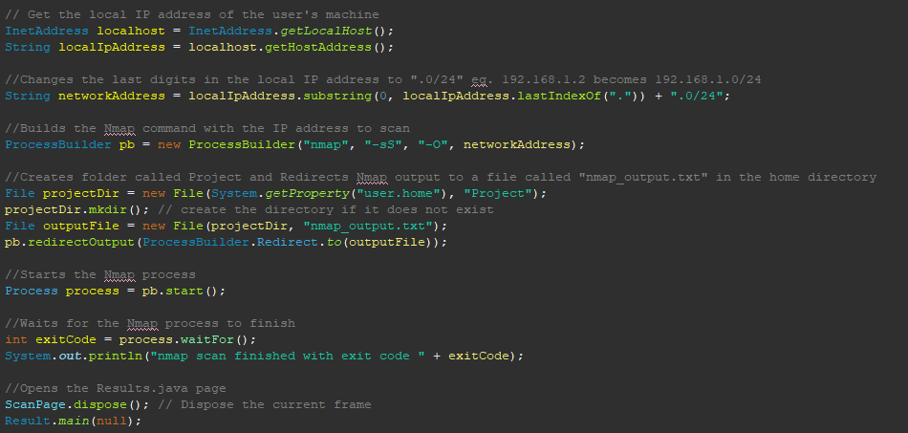

It then takes this IP Subnet and performs an intense Nmap scan (nmap -sS -O 192.168.1.0/24) on the IPs 192.168.1.0 to 192.168.1.254. The finished scan results are then stored in a file called ‘Project’ that is created in the user’s home directory folder. After the scan is completed, it opens the Results page of the GUI that displays the Device Name, IP Address, Mac Address, OS, and Manufacturer from the stored results in the file, if the file is not found, it will prompt the user to perform a scan.
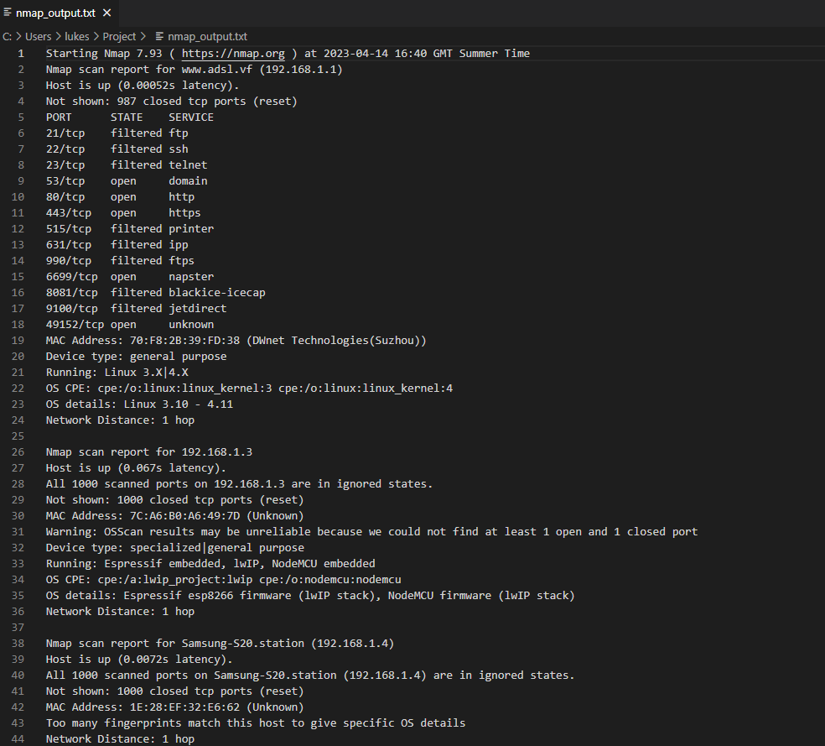

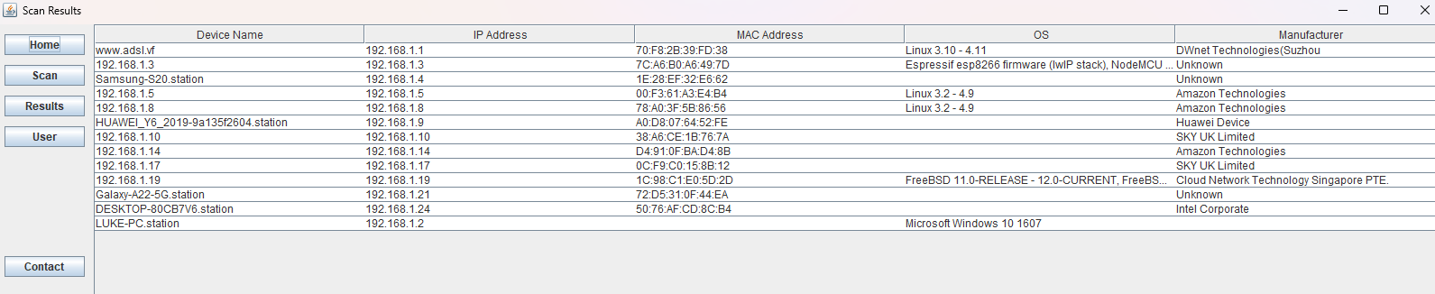

The User’s page was added as an extra feature, this feature is a manual way for the user to track who they allow to connect to their network. The purpose is for the user to take a note of the “Permanent” or “Temporary” users that they allow to connect to the network. Permanent being people that live in the house full time and Temporary being visitors. The code uses a file created in the same “Project” folder as the scan results and updated every time the user adds a person to the list. It is just as easy to remove someone from the list as it is to add them, In the table displaying the persons name, in the third cell of every row there is text “Click to Delete User”, clicking on the third cell will remove that user from the list and then update the stored file.
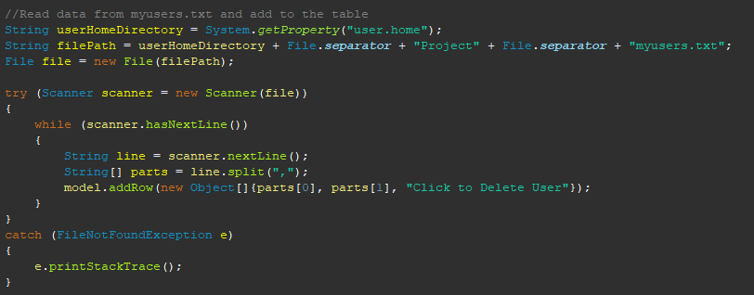

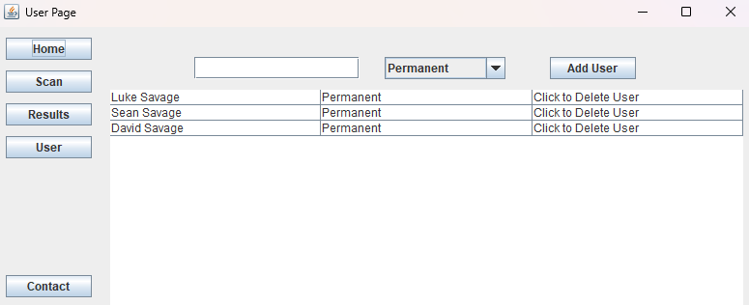

Description of Conformance to Specification and Design
The submitted product doesn’t completely match my original specification and design. While most of it does match my original ideas, such as the Scan Page and the Results page. In my original draft of this project there was no users page but there were more features to be added in the Devices Page.

While the Device page does include the information from the row as expected, it doesn’t allow the user to perform a scan on that device for any security errors such as out of date OS or known issues for that device that may not have been updated, etc and having this information it would have given a security rating based on the vulnerabilities the devices may have. The reason as to why this feature was not added was that I could not find any way to automate a scan for every device possible, as the range of devices in one household compared to another can be very large.

Description of Learning

Technical Learning
I learned a lot when working on this project, such as the importance and benefits of a Threat Analysis, I have also learned how and when a Threat Analysis should be performed. There are many Threat Analysis tools on the market, one of which I used during my work placement in third year (ConnectWise).

I also learned a lot about the Home Network Environment, such as the huge range of devices that are used in a single household. As well as the difference of one household devices to another set of household devices. I learned more about a threat analysis that is specific for the household as the majority that are performed are for organizations. I also studied some of the existing home network security techniques and the pros and cons of having these techniques in place on the home network.

I learned a lot about network discovery, how it works and the different types of Network Discovery Tools. Like Threat Analysis Tool, there are many Network Discovery tools on the market, some of the most notable I found were Nmap (also known as Network Mapper and Zenmap), Angry IP Scanner and Fing. For a home user that may not be very tech-savvy, I would recommend Fing out of the three tools. Fing accurately shows the devices on the network, some security issues that may face each device and the network.

Throughout the project I have learned an extensive amount of Java. Using it for the whole GUI and functions in the project, I have learned how many commands and statements work. I also learned how to work code that I found quite difficult in my previous years on college, such as getting the code to save and update files on the device. I also figured out how to get the code to work with Nmap.

Personal Learning
Throughout the process of this project, I have learned a lot about different things, including myself. Some of the things that I have learned about myself is that if I put my head down and focus on the work ahead, I can do things that I previously convinced myself I couldn’t.

I also learned that I could work well while under pressure; under pressure to meet deadlines and to get the work done to the best of my ability, with the tools I have at hand and the time frame I had to meet.

Learning to accept the limitations I came across and acceptance that I couldn’t do everything that I wanted to do will help me approach issues in a more mature way in the future.

Review of Project
I feel that the project went well all things considered, such as the tools I had, the time constraint and more. I used a lot of my time testing Network Scanners to get the most accurate result and ultimately chose Nmap as the way to proceed. I feel like this was the correct option due to the fact that it works with Java code even though it was a pain to get working with the code and that it provided me with a list of devices and their associated information. What I would say the biggest issue or what went wrong with this project was that I didn’t do more with the Devices page, I would have liked to have a better Gui/ display for the results in the row and also add an extra feature into the page to have either more security for the network or just that device.

If I were to start this project again, I would spend less time looking for the network scanner that suited me as I wasted a lot of my time on this search that I shouldn’t have as I still went with the first and best choice, nmap. Since many Network Scanners haven’t been optimized for either Windows or even Windows 11, they were not as accurate as I hoped. If less time were spent on the search for a Network Tool, I could have had more time to research and implement more features and automation into my project.

If someone were to attempt a project similar to this one in the future, I would advise them to spend most of their free time at it, and to search but not spend too much time on looking for the right tools for them. Like mentioned above, I spent too much time searching for the tools right for me, I had to settle on what I used as I didn’t leave myself with much time to work on the actual project part. I would also look more into ways of automating some features and making some tweaks to the layout here and there to make it better and smoother to use.

Personally, I feel like I made the right choice when it comes to the technology I used throughout the project, while it was only really Java and Nmap I feel like the choice was solid. Since I studied Java for two years in my course and I was familiar with the Eclipse IDE, I felt most comfortable doing my code in that language, and with Nmap I feel like that was the right choice because it displays the best results from the scanner tools that I looked into, it works on multiple operating systems, and it is quite easy to use overall.

Overall, I fell like my project was a success as it covered the majority of what was required, plus an extra feature. Although I do feel like I could have also done it much better and was frustrated that the scanners couldn’t accurately scan the network and provide me with the required information.

Acknowledgements
For the duration I was helped by many people, whether it was for a moment or for the entire process. Also, whether it was to test the code, to provide me with vital information or to help me with my code.

- I would like to thank my project supervisor Paul Barry for working with me throughout the whole process, making sure I meet deadlines and keep ahead of any presentations and work.

- I would also like to thank my friends and family that provided me with a list of the devices that connect are on their network, as it helped with my research for the project and more.

- I would also like to thank a select few of my friends, from my course as they helped me with the code in the project and helped me test the project to see if it will work on different networks and operating systems.

- Finally, I would like to thank my not so tech-savvy family for being test subjects to see if I made the GUI easy to understand and use for anyone that is not accustomed to using a Desktop or Laptop.

Plagiarism Declaration
I declare that all material in this submission is entirely my own work except where duly acknowledged. I have cited the sources of all quotations, paraphrases, summaries of information, tables, diagrams, or other material; including software and other electronic media in which intellectual property rights may reside. I have provided a complete bibliography of all works and sources used in the preparation of this submission. I understand that failure to comply with the Institute’s regulations governing plagiarism constitute a serious offence.

Student Name: Luke Savage
Student Number: C00248077
Date: 17/04/2023

